**EEE361**

**ASSIGNMENT**

**SET-7**

1. a) According to this figure, if it’s possible to create magnetic monopoles in a spherical closed surface, then find out the amount of total magnetic flux.

N

N

N

S

N

Also, find div $\overline{F}$ and curl for = x2y – (z3 – 3x) + 4y2

b) For ε= 2.5εo, µ=10µo; Determine whether these following pairs satisfy Maxwell’s equations or not. [Detailed work is mandatory]

* $\overline{E}$ = 2y y ,  = 5x x
* = 100 sin(6×107t) sin(z) y ,  = -0.1328 cos(6×107t) cos(z)x
* = (z + 6×107t) x ,  = -754z - 4.52×1010t y

1. a) Given, = m sin(x) sin (t) y and = m/µo cos(x) cos (t) z. Determine whether these fields satisfy Maxwell’s equations or not.

b) Given that, in free space = m sin (wt-βz) y. Find $\overline{D}$, $\overline{B}, \overline{H}$ and d. Then show that $\overline{∇}.\left(\overline{∇}×\overline{H}\right)$ =0.

c) Identify weather these functions satisfy the wave equations or not. Show all the calculations.

1. $B = \frac{10}{ρ} cos (ωt - 2ρ) a_{∅}$ (This is Cylindrical co-ordinate [ u can use internet to know the calculation process])

$sinω (100z + 50t)$

1. a) Given the magnetic field intensity

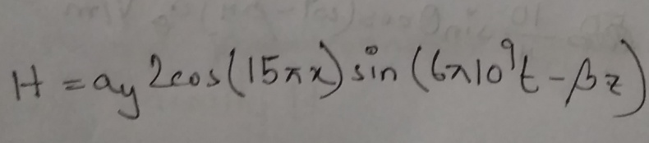

in air. Using this information and the knowledge of Maxwell’s equation, find the electric field intensity E and the constant β.

1. In free space, the electric field intensity is defined by

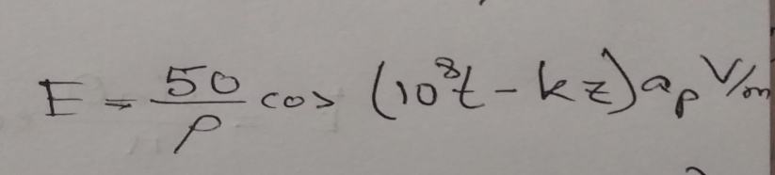

Using this information and the Maxwell’s equation,

find the constant k, displacement current density, Jd and magnetic field intensity H.

1. a) Explain with proper figures (in detail): In the Faraday’s electromagnetic equation (also known as Maxwell’s 3rd equation), why the sign of the time derivative is negative but the curl part (of electric field) is positive.

Also explain in detail (with proper figures): if the sign ‘were’ positive, what would happen!!!!

b) (i) calculate the divergence of this function: 25xyz + 19xy+ 30xz  
(ii) calculate the curl of this function: 25xyz + 19xy+ 30xz

(iii) Calculate the gradient of this function: 25xyz + 19xy+ 30xz

c) (i) In the primary circuit, why do we always use AC voltage source instead of DC voltage for real world applications?

(ii) Why do we use round shaped coils (I.e. Round shaped turns in the coils) in both the primary and secondary circuits [If those coils were not round shaped, what would be the problem]?

*** You should draw figures to make your explanations strong.

1. A uniform plane wave in air with electric field intensity.

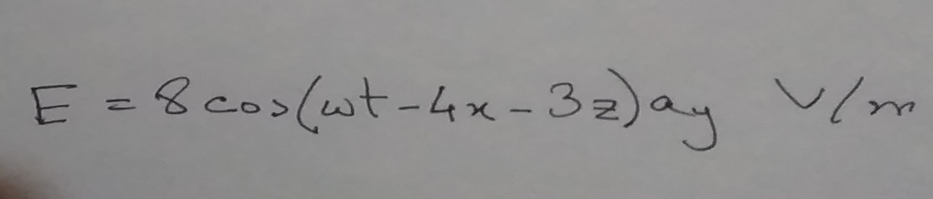

is incident on a dielectric slab (z>=,0) with

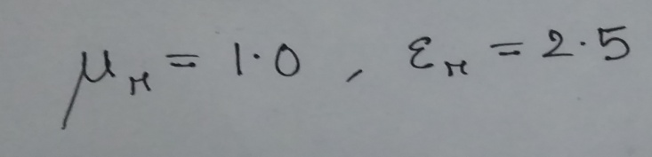

Find the angle of incidence and

1. The propagation vector for incident, transmitted and reflected fields.
2. The reflected electric field Er and reflected magnetic field Hr
3. The transmitted electric field Et and magnetic field Ht

